Experiment 1:Write a Python program to solve the 8-Puzzle problem

Aim
To write a Python program to solve the 8-Puzzle problem using the Best First Search (A* Search) algorithm.

Algorithm(BFS)
- Define the initial state and goal state.
- Calculate the heuristic value (number of misplaced tiles).
- Store the initial state in the open list.
- Select the node with the minimum heuristic value.
- Generate all possible child states by moving the blank tile.
- Repeat the process until the goal state is reached.
- Display the solution path.

Program
from queue import PriorityQueue

goal = [[1,2,3],
[4,5,6],
[7,8,0]]

moves = [(-1,0),(1,0),(0,-1),(0,1)]

def heuristic(state):
h = 0
for i in range(3):
for j in range(3):
if state[i][j] != 0 and state[i][j] != goal[i][j]:
h += 1
return h

def find_blank(state):
for i in range(3):
for j in range(3):
if state[i][j] == 0:
return i,j

def copy(state):
return [row[:] for row in state]

def solve(start):
pq = PriorityQueue()
pq.put((heuristic(start), start))
visited = []

while not pq.empty():
h, state = pq.get()

if state == goal:
print("Goal State Reached")
for row in state:
print(row)
return

visited.append(state)

x,y = find_blank(state)

for dx,dy in moves:
nx,ny = x+dx,y+dy
if 0<=nx<3 and 0<=ny<3:
new = copy(state)
new[x][y],new[nx][ny]=new[nx][ny],new[x][y]

if new not in visited:
pq.put((heuristic(new),new))

start = [[1,2,3],
[4,0,6],
[7,5,8]]

solve(start)

Output
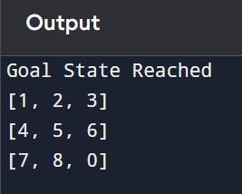

Result
Thus, the Python program to solve the 8-Puzzle Problem using Best First Search (A* heuristic) was implemented successfully and the goal state was reached.

